Name: Jay Rajesh Umap

Roll No.: 2205010

Enrolment No.: MITU20BTIT0029

Class: LY IT Core

Lab Assignment No.: 6

Create your own cloud on your device.

ownCloud:

ownCloud is a popular open-source software platform that provides a self-hosted file sync and share solution. It enables users and organizations to create their own private cloud storage and collaboration environment. With ownCloud, you can store, sync, and share files, documents, photos, and other data securely while retaining control over your data and the server on which it's hosted.

Key features of ownCloud include:

1. File Synchronization: Users can synchronize files across devices, ensuring that the latest version of a file is accessible from any device with ownCloud installed.
2. Data Security: ownCloud offers data encryption at rest and in transit to protect sensitive information. You can control who has access to your data and what permissions they have.
3. Collaboration: ownCloud supports document editing and real-time collaboration, making it a platform for team collaboration and file sharing.
4. Customization: ownCloud is highly customizable, allowing users to tailor the platform to their specific needs and requirements.

Overall, ownCloud provides individuals and organizations with the flexibility to create their own secure cloud storage and collaboration solutions, ensuring data privacy and control while enabling seamless access to files and collaboration tools.

Steps:

1. Download ownCloud Appliance: [https://owncloud.com/download- server/](https://owncloud.com/download-%20server/)
2. Launch Virtual Box after appliance is installed on the system and import the ownCloud appliance

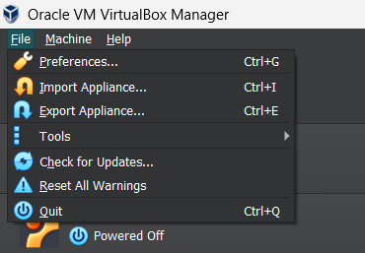

1. 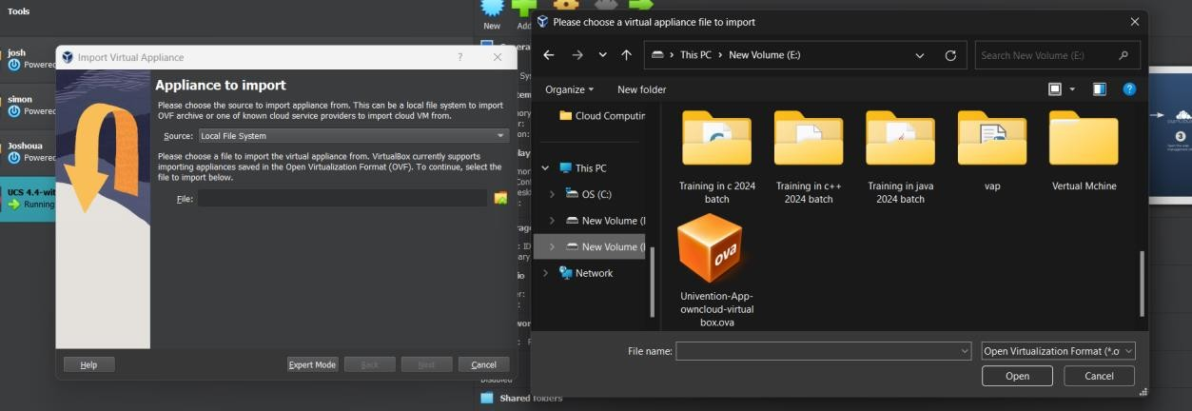Select OVA file of ownCloud which we have downloaded and click “open”

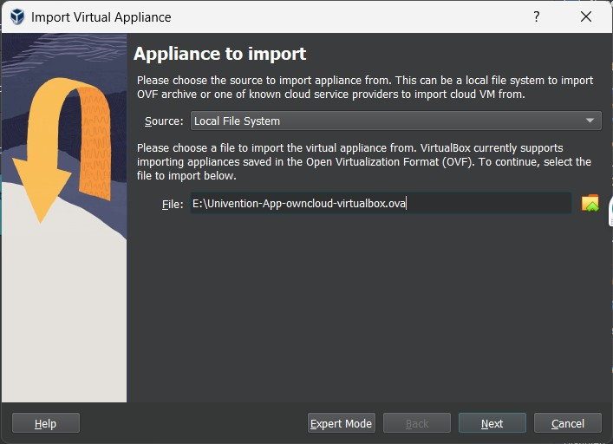

1. Click "Import" to begin the import process. This may take some time, depending on your system's performance and the size of the appliance.
2. Click the "Start" button boot VM
3. Set up ownCloud: After the virtual machine has booted, you'll need to follow the on-screen

instructions to set up your ownCloud instance. This typically involves configuring the database, admin user, and other settings.

1. Once the setup is complete, open a web browser on your host machine and enter the IP address or hostname of the ownCloud virtual machine to access the ownCloud web interface.
2. Setup location and time zone

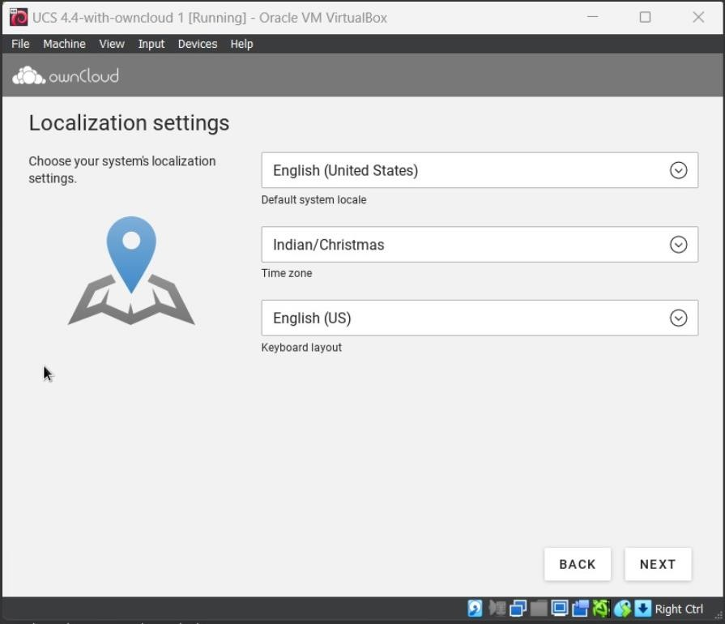

1. Setup network configurations

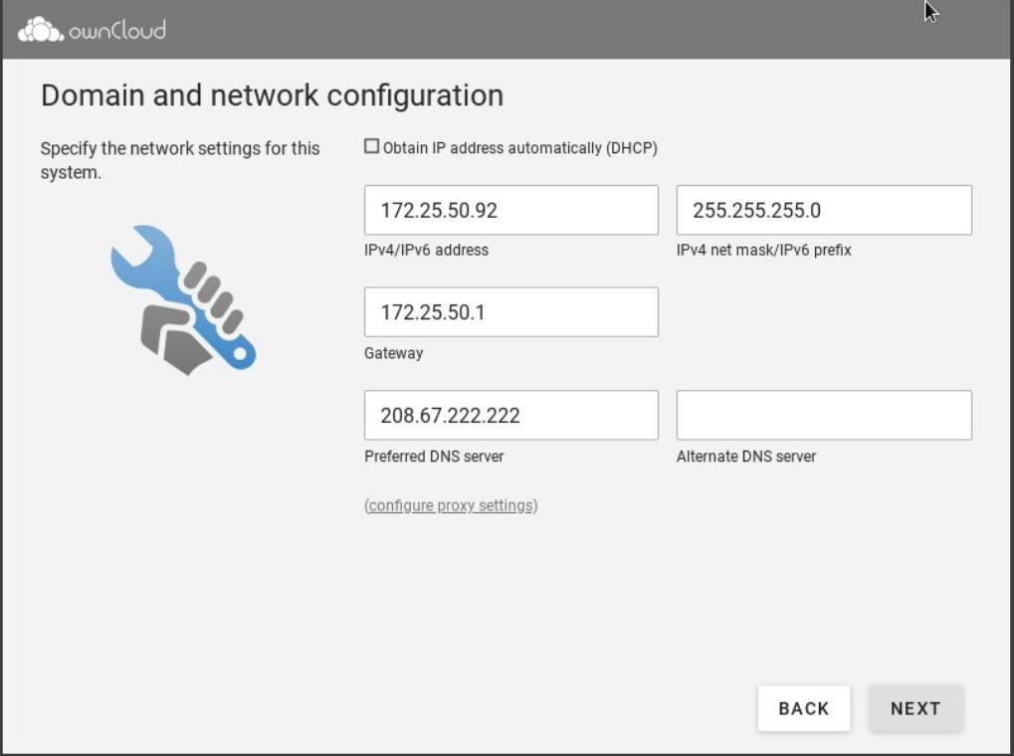

1. Enter account details such as your name, email and password and confirm the configuration settings

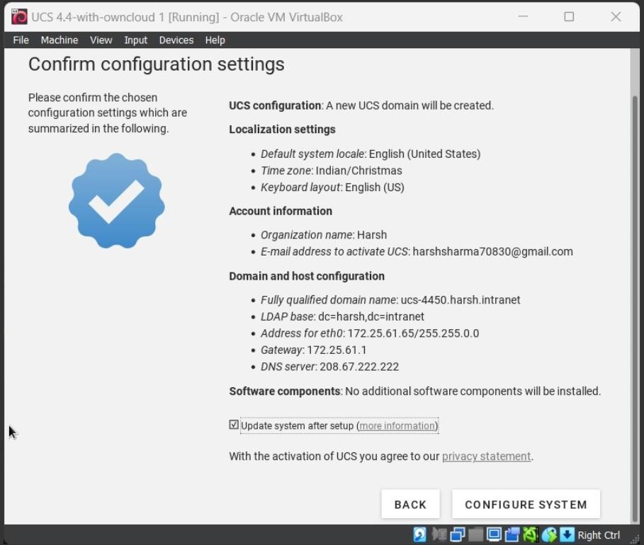

1. Click on configure system

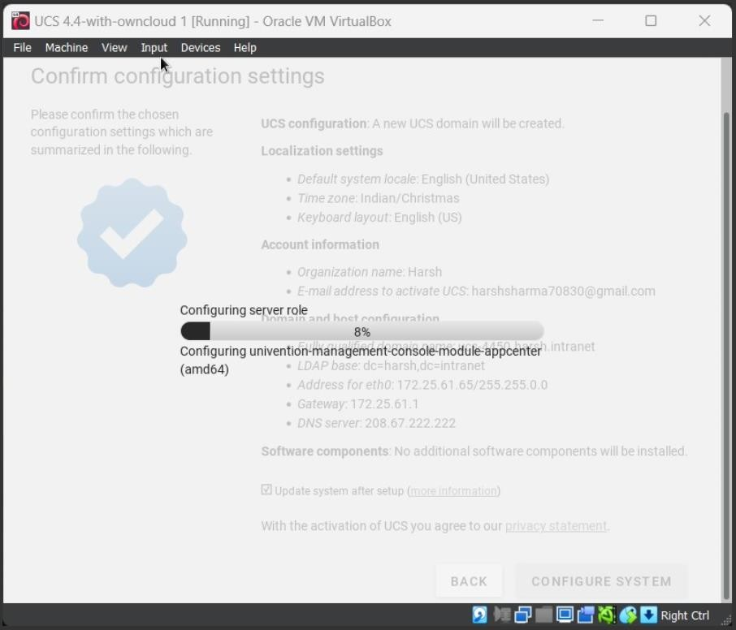

1. Login using your credentials which you used while setup and now you can use ownCloud for managing and accessing your files.

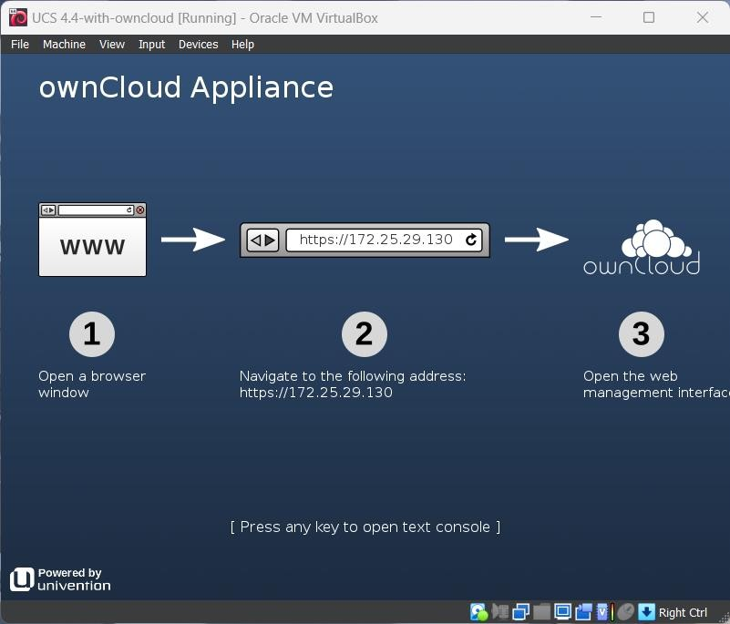

1. Open the URL given on the above screen this will redirect your to your ownCloud homepage

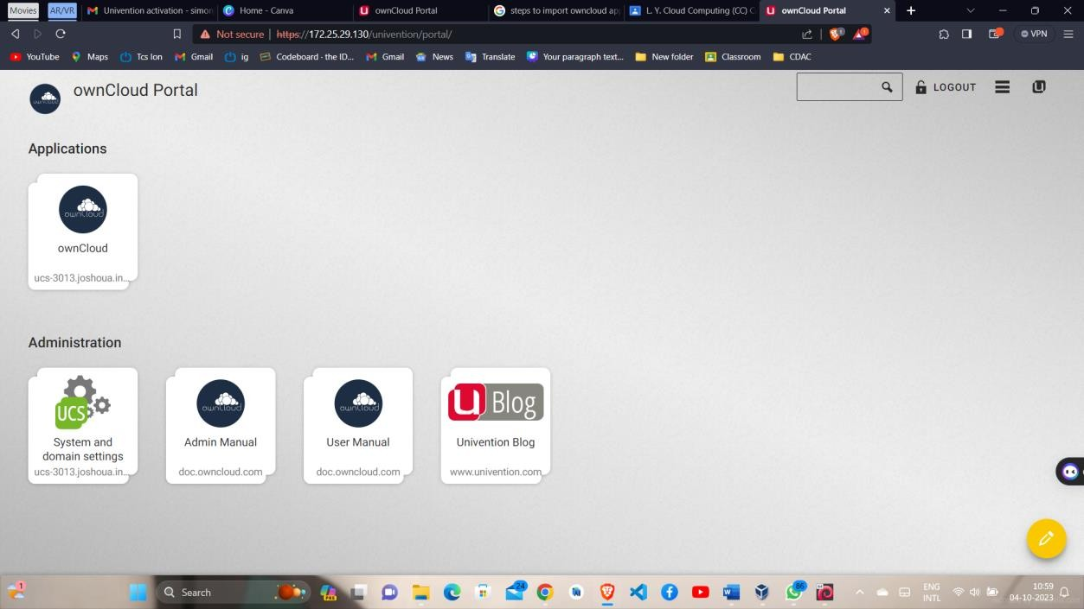

# Conclusion:

That's it! You've successfully imported the ownCloud appliance into VirtualBox and can start using it for your file and data management needs.